OCT Engine Serial Command Reference

# Revision History

|  |  |
| --- | --- |
| Date | Changes |
| 5/3/2017 | * New commands in OCTX firmware   Updated by: J. Price and J. Traud |
| 1/25/2015 | * Pramp command inputs. The specification for this function has been updated in preparation for an end user.   Updated by: J. Traud |
| 12/2/2015 | * Revised Document Layout * Commands for linear ramping modes changed   Updated by: J. Traud |

Contents

Revision History 1

Galvo Commands 2

Sweep Commands 3

Motor Commands 6

# Galvo Commands

|  |  |
| --- | --- |
| **Command:** | ver |
| **Response:** | Ver:#.##\r\nA\n |
| **Remarks:** | Responds with firmware version and model type. |

|  |  |
| --- | --- |
| **Command:** | reset |
| **Response:** | none |
| **Remarks:** | Resets microcontroller, but not USB. Must plug and unplug USB cable to reconnect. |

|  |  |
| --- | --- |
| **Command:** | dfu |
| **Response:** | A |
| **Remarks:** | Activates the firmware update mode. Will last 3 seconds before deactivating. |

|  |  |
| --- | --- |
| **Command:** | ping |
| **Response:** | A |
| **Remarks:** | Tests to see if the board is active. Command only responds with an acknowledge |

|  |  |
| --- | --- |
| **Command:** | focus <value> |
| **Response:** | A |
| **Remarks:** | Voltage control for the liquid lens. Can be any value between 0 and 4095. Will respond with setting if value not entered |

|  |  |
| --- | --- |
| **Command:** | foci <value> |
| **Response:** | A |
| **Remarks:** | Voltage control for the intensity liquid lens. Can be any value between 0 and 255. Will respond with setting if value not entered |

|  |  |
| --- | --- |
| **Command:** | out1, out2 <value> |
| **Response:** | A |
| **Remarks:** | Sets output off if value = 0 on for other values and current state if no value given. |

|  |  |
| --- | --- |
| **Command:** | eer <value> |
| **Response:** | Page of hex values stored in the EEPROM. |
| **Remarks:** | Value can vary depending on EEPROM size. No value defaults to page 0. |

|  |  |
| --- | --- |
| **Command:** | eew <Location> <value> |
| **Response:** | A |
| **Remarks:** | Write byte in Value to Location. |

# Sweep Commands

|  |  |
| --- | --- |
| Command: | <Variable> <#####> |
| Response: | “ok.\n” |
| Remarks: | Will respond with current setting if value not entered. |

|  |  |  |  |
| --- | --- | --- | --- |
| Variable | Range | Default | Function |
| a_scans | 2-65535 | 1000 | Sets the number of trigger steps for each sweep. Set before filling x ramp and y ramp. |
| b_scans | 0-65534 | 0 | Sets the number of A scans per B scan. If zero then X and Y sweep in sync. Multiple of 2. |
| delay | 0-65535 | 50 | (In µs) Time between pulses sent to the camera. Minimum value of 3. |
| pulse | 0-65535 | 5 | (In µs) Duration of Camera Pulse. If set to zero no trigger pulses occur. |
| t_ret | 0-255 | 7 | (In µs) Duration of return pulse + delay (but no trigger) |
| A_div | 0-65535 | 1 | Scales the return path time. The return path has the same amount of counts as a scanning path. This value multiplies how fast the return counter increments. |
| Phase | 0-65535 | 100 | Adjust phase relationship between mirror positioning and triggering. |
| trigger | 0-255 | 0 | Return trigger enable. If set to zero then no triggers appear on the return sweep and the return time is active. If non-zero, triggers occur on both parts of the sweep. |
| a_hold | 0-65535 | 0 | Number of triggerless pulses between a scans. For stabilization of mechanics. |
| b_hold | 0-65535 | 0 | Number of triggerless pulses between b scans. For stabilization of mechanics. |
| trdelay | 0-65535 | 0 | Delay before first trigger |
| trdmode | 0, 1 | 1 | A value of 1 adds the trigger delay to the beginning and end of a sweep. |

|  |  |  |
| --- | --- | --- |
|  | | **Figure 1:** Camera Line Trigger structure. This structure is controlled by setting the registers pulse and delay. For 1-D scans without triggering on the recovery the equivalent pulse with is t_ret. |
| **Command:** | xramp <start> <stop> xramp <start> <stop> <repeated scans> yramp <start> <stop> yramp <start> <stop> <repeated scans> xy_ramp <start> <stop> <X start> <X stop> <Y start> <Y stop> xy_ramp <start> <stop> <X start> <X stop> <Y start> <Y stop> <repeated scans> | |
| **Response:** | values for x and y ramp | |
| **Remarks:** | Fills the x or y buffer linearly from start to stop. This command also uses the a_scan and b_scan values. Where a_scan is the amount of data points collected per line. The b_scan value is used in xy_ramp mode where it is the amount of incremental lines performed in the defined space.  Start. The starting X or Y coordinate from 0 to 65,535.  Stop. The starting X or Y coordinate from 0 to 65,535.  Repeated Scans. This is an optional value (defaults to 1). This is the amount of times each line (b_scan) is repeated before moving forward. This is used in higher resolution averaging modes where multiple b_scans are taken and then the result is averaged. | |

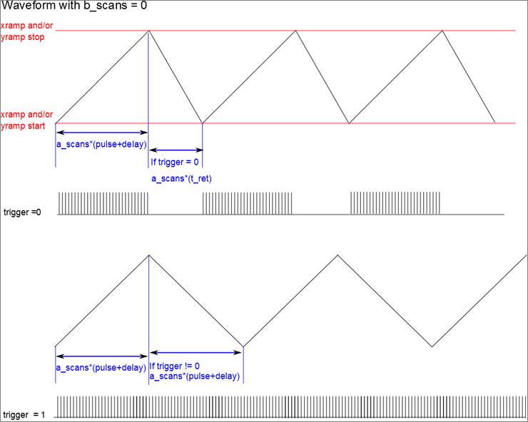

|  |  |
| --- | --- |
| **Command:** | pramp <Center X> <Center Y> <radius> <reps> |
| **Response:** | A |
| **Remarks:** | Polar ramp function. The center values will indicate the center position for the scan in DAC values and the radius indicates the radius. The number of a-scans is the number of data points collected per circle. B_scan is the amount of concentric circles scanned. The input “reps” value is the amount of times each circle is repeated. |

|  |  |
| --- | --- |
| **Command:** | sramp <Center X> <Center Y> <radius> |
| **Response:** | A |
| **Remarks:** | Spiral ramp function. The center values will need to be DAC values that fit in the range of 0-65536.  The number of a-scans is the number of data points collected per b_scan. The value for b_scans is also the amount of spirals in the waveform. Scan pattern is that of an Archimedean spiral. |

|  |  |
| --- | --- |
| **Command:** | scan <count> |
| **Response:** | A |
| **Remarks:** | Initiates a scan. If no arguments or if count is negative , the system scans indefinitely, Otherwise, the system will scan the number of times specified by the count. In vector mode, count is the number of single b-scans to complete. In either of the two raster modes, count signifies the number of c-scans to complete. Count can be set to +/- 2,147,483,648. |

|  |  |
| --- | --- |
| **Command:** | ntscan |
| **Response:** | A |
| **Remarks:** | As above but without triggers |

|  |  |
| --- | --- |
| **Command:** | stop |
| **Response:** | A |
| **Remarks:** | Stops scanning at the end of the current b scan. Will turn off mirrors. |

# Motor Commands

|  |  |
| --- | --- |
| **Command:** | msset q, p, i or h <value> **Not implemented.** |
| **Response:** | A |
| **Remarks:** | Set top speed of motor. Will respond with current setting if value not entered. |

|  |  |
| --- | --- |
| **Command:** | maset q, p, i or h <value **Not implemented.** |
| **Response:** | A |
| **Remarks:** | Set acceleration of motor. Will respond with current setting if value not entered. |

|  |  |
| --- | --- |
| **Command:** | mgr q, p, i or h <value> |
| **Response:** | A |
| **Remarks:** | Send motor to relative location given in value. |

|  |  |
| --- | --- |
| **Command:** | mg2 q, p, i or h <value> **(Currently Disabled)** |
| **Response:** | A |
| **Remarks:** | Send motor to absolute location given in value. |

|  |  |
| --- | --- |
| **Command:** | mgh q, p, I, h or a **(Currently Disabled)** |
| **Response:** | A |
| **Remarks:** | Send motor to home location. |

|  |  |
| --- | --- |
| **Command:** | mgd q, p, i or h <value> |
| **Response:** | A |
| **Remarks:** | Turn motor on. 0 for one direction, non-zero for reverse direction |

|  |  |
| --- | --- |
| **Command:** | mstop q, p, I, h or a |
| **Response:** | A |
| **Remarks:** | Stop motor, or all motors. |

|  |  |
| --- | --- |
| **Command:** | minfo |
| **Response:** | A |
| **Remarks:** | Responds with location and destination for each motor. |

|  |  |
| --- | --- |
| **Command:** | mih q, p, I, h or a |
| **Response:** | A |
| **Remarks:** | Responds with 0 if motor not home else unique hexadecimal bit if home. 'a' will respond with hexadecimal number each bit representing different home sensor. |